**NTR TRUST NEWS BULLETIN (No. 23)**

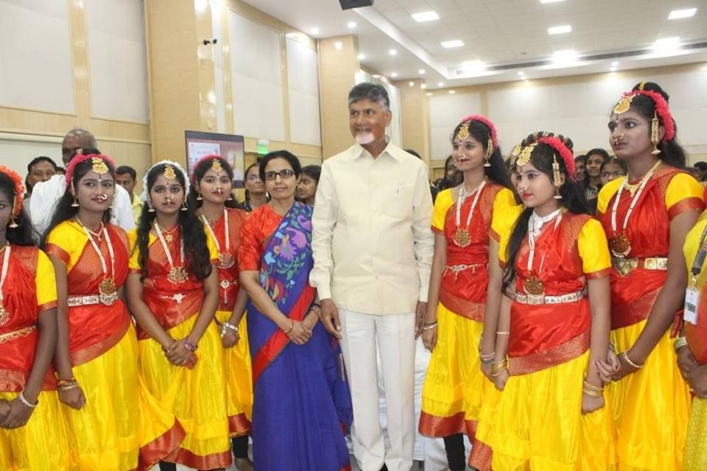We are happy to share with you NTR Trust’s e-News Bulletin for the months of Jan and Feb 2019. We will be happy to have your feedback.

***Hon’ble Chief Minister of AP & Founder Trustee of NTR Trust, Sri Nara Chandrababu Naidu & Managing Trustee Smt. Nara Bhuvaneshwari during their interaction with NTR Model School students in Amaravati***

# HIGHLIGHTS

1. NTR Trust's calendar event - Legendary Blood Donation Drive (LBD) - was inaugurated by our Managing Trustee Smt. Nara Bhuvaneswari garu on 18th January 2019. LBD-2019 was held at more than 110 locations across Andhra Pradesh & Telangana in collaboration with Red Cross, Rotary, Lions, Govt and other Blood Banks and with support from thousands of Volunteers.
2. TDP National President, Chief Minister of AP & Founder Trustee of NTR Trust, Sri Nara Chandrababu Naidu took part in Annual Day Celebrations at NTR Model School & College, Gandipet.
3. Hon'ble CM of Andhra Pradesh Sri Nara Chandrababu Naidu along with Managing Trustee Smt. Nara Bhuvaneshwari interacted with students from NTR Model Schools studying in Challapalli and Warangal branches in Amaravati.
4. Mr. T. Vishnu Vardhan will be transitioning from the role of CEO NTR Trust on 28 February, 2019. Mr. K. Rajendra Kumar (Retd. DGP of J&K) will be taking charge as the new CEO of NTR Trust from 1 March, 2019.

# [HEALTH](http://ntrtrust.org/health-care/)

**Key Activities:**

1. A free health check-up camp at Mylavaram, Krishna district was organized by NTR Trust in collaboration with Ayushman Hospital & Lions Club. 435 residents came for the health check-up.
2. A free health check-up camp at Velpuru village, Penamaluru Constituency, Krishna district was organized by NTR Trust in collaboration with Bode Prasad Charitable Trust, & Capital Hospital. 278 residents came for the health check-up.
3. NTR Trust in collaboration with Dr. C.L. Venkatrao & Team, organized a Free 2 days Medical Camp at Gudlavalleru village, Krishna district. 198 residents came for the health check-up.

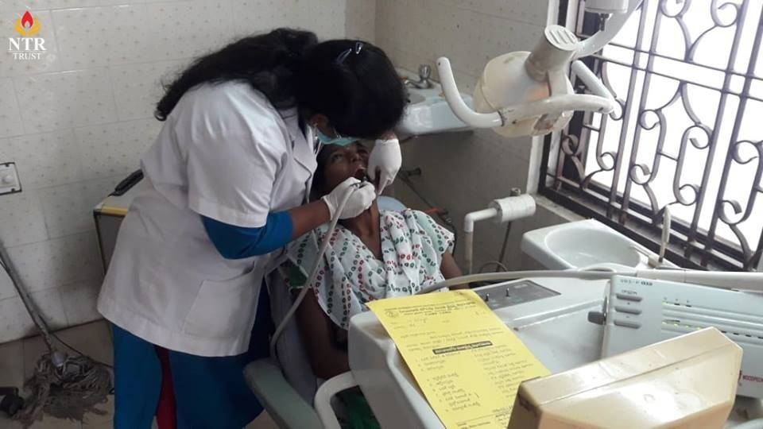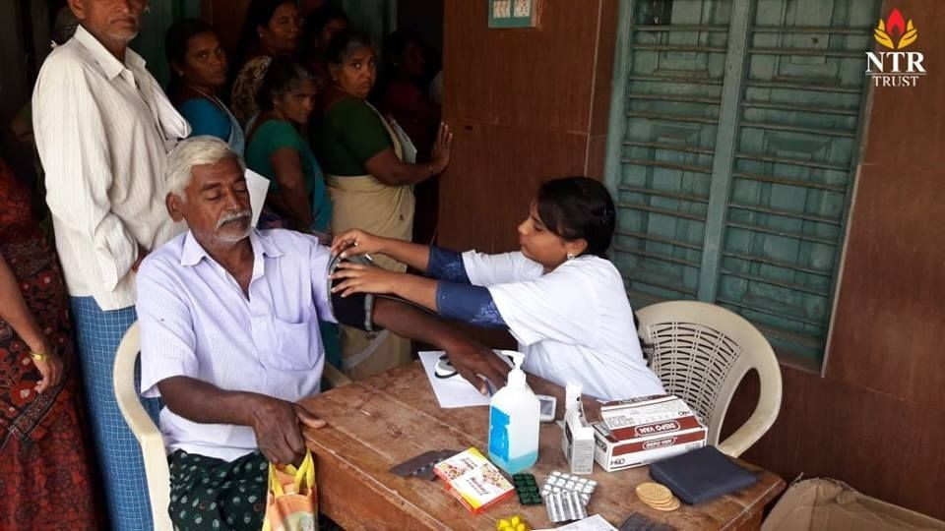

***Medical check-up in progress @ Gudlavalleru Village***

1. LBD-2019 was formally inaugurated by NTR Trust Managing Trustee Smt. Nara Bhuvaneswari garu along with NTR Trust CEO Mr. T. Vishnu Vardhan, COO-Education Mr. Y.Mohan Rao & Director-Education Mr. N.S.Prasad at NTR Trust bhavan. NTR’s Vardhanthi (Death Anniversary) has been observed as “Legendary Blood Donation Drive”. After paying tributes to legend NTR, Smt. Nara Bhuvaneswari garu addressed the volunteers across the Telugu states through the media and thanked everyone for voluntarily donating blood to save precious lives.

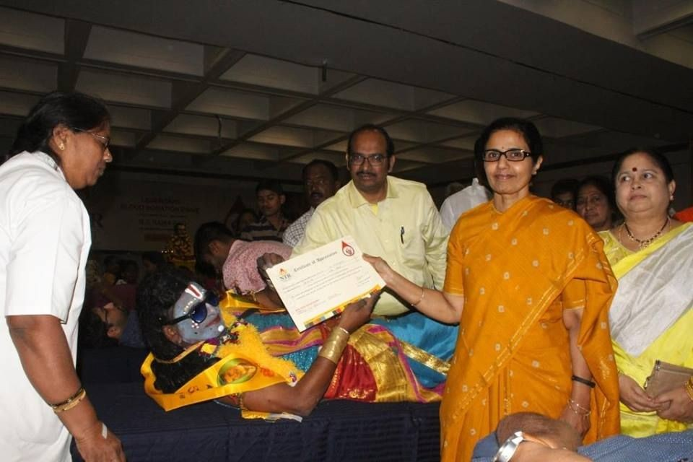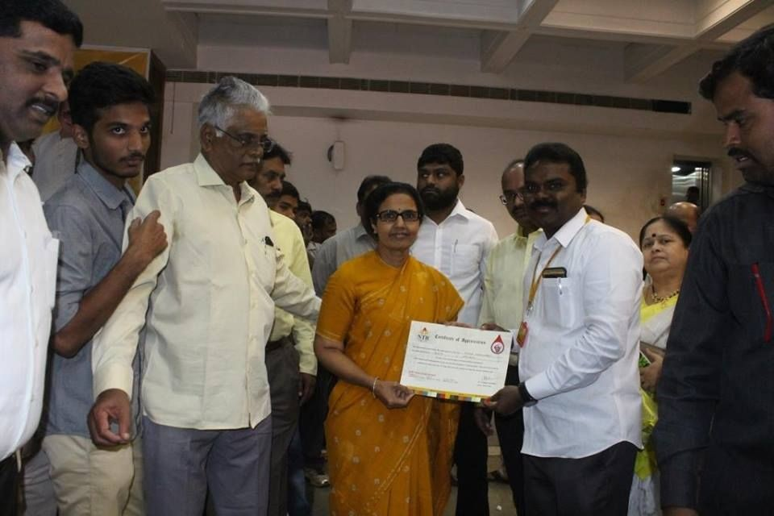

***Managing Trustee Smt.Nara Bhuvaneshwari felicitating voluntary Blood donors during LBD-2019***

1. A blood donation drive was organized by NTR trust in association with NTR Fans - Muscat, Sultanate of Oman, Arab country on the occasion of "Legendary Blood Donation Camp 2019". 181 donors voluntarily came forward to donate blood.

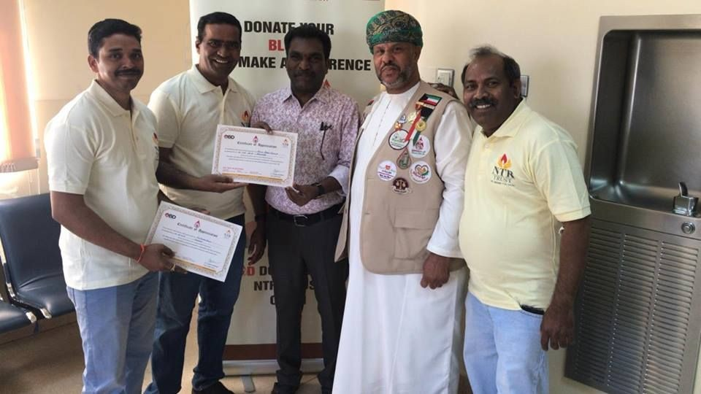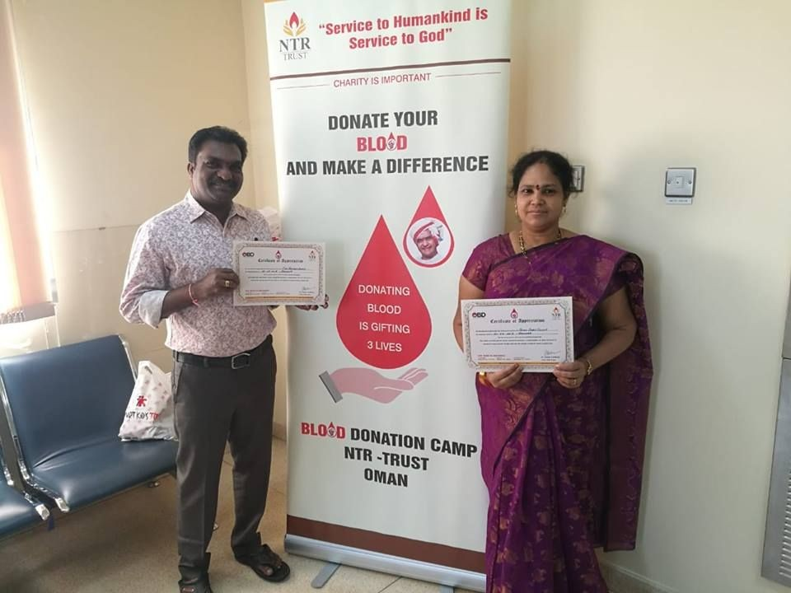

***Distribution of certificates to Voluntary Blood donors of Oman during LBD 2019***

1. A Blood donation camp was organized by NTR Trust at Yelamanchili & Bakkannapalem, Visakhapatnam. 67 donors voluntarily came forward to donate blood.

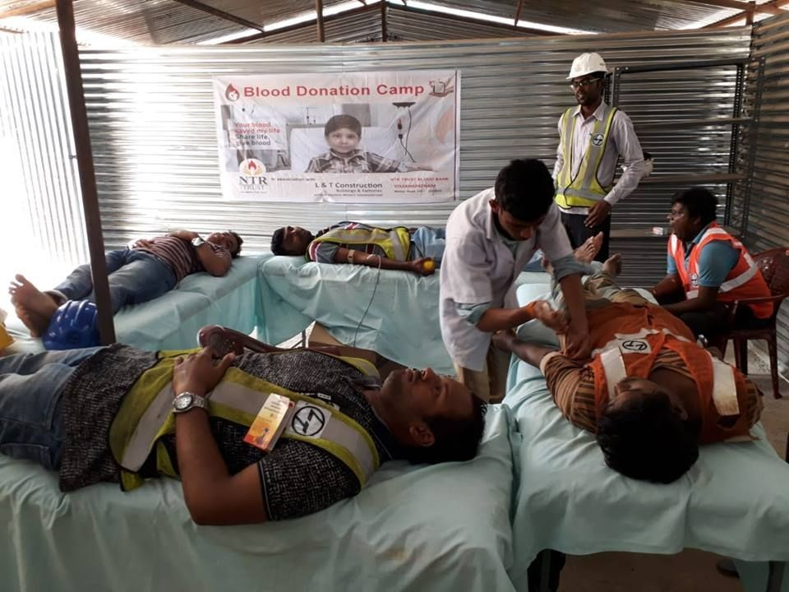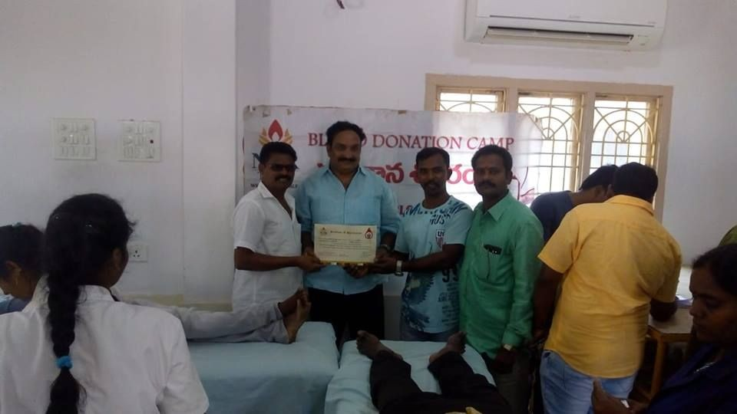

***Voluntary blood donation in progress Felicitation of voluntary Blood donors***

1. A free health check-up camp at Alluru Village, Kurnool district was organized by NTR Trust in collaboration with Heritage Foods Ltd & Shanthiram Hospital, Nandyala. 589 residents came for the health check-up.

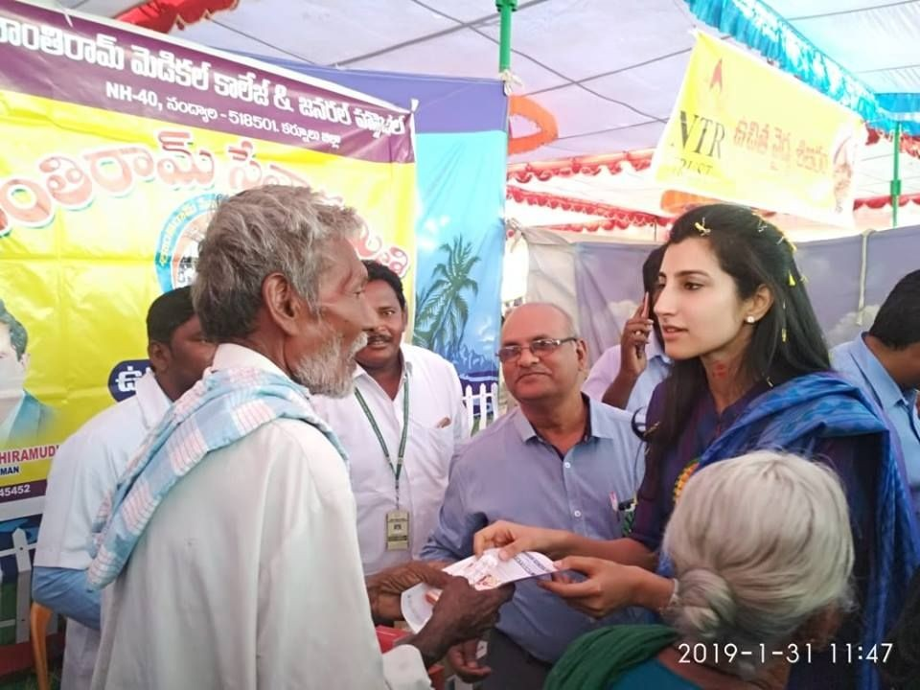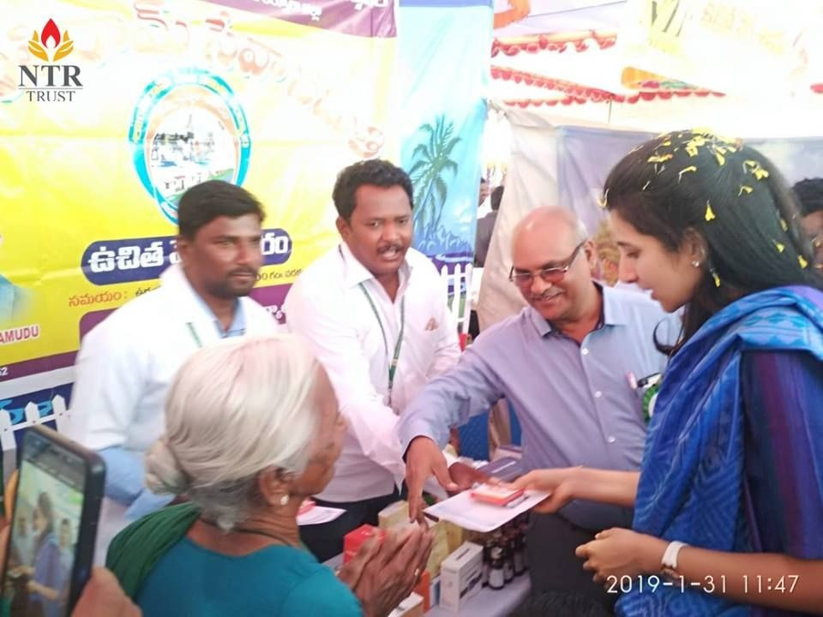

***Smt.Nara Brahmani, Trustee NTR Trust, distributing free medicines at Alluru Village Medical Camp***

1. During Jan and Feb 2019, NTR Trust organized free Medical Camps across Andhra Pradesh and Telangana, wherein people were given free health checkup. These Healthcare camps aim at promoting health-seeking behaviour in the long term and these camps majorly work on building awareness regarding common ailments, nutrition, hygiene and sanitation. These camps provide comprehensive health services free of cost.
2. During Jan and Feb 2019, NTR Trust Blood Banks have organized numerous Volunteer Blood Donation Camps across the state of Andhra Pradesh and Telangana.

# Press & Media Coverage:

1. [Eenadu - Hyderabad](https://drive.google.com/file/d/1wAtk6TY4ly_FaeS4dTVWt5S-BSjyeIqu/view?usp=sharing)
2. [Andhra Prabha - Hyderabad](https://drive.google.com/file/d/1Qg5XrLNWwVDZS3TvV6on4WxOfFu24gsJ/view?usp=sharing)
3. [Andhra Jyothi - Jagtyal](https://drive.google.com/file/d/1U4sB8kuJaIXo79NwUemDy2MN4HW4GruS/view?usp=sharing)
4. [Vaartha - West Godavari](https://drive.google.com/file/d/1r3fvaKcmwMnA7BpcLiItXNIf_-Ll6Lok/view?usp=sharing)
5. [Vaartha - Vijayawada](https://drive.google.com/file/d/1XYRYjC94H1xuNsKJk5_kf3cy9lh6xPNK/view?usp=sharing)
6. [Andhra Jyothi - Hindupur](https://drive.google.com/file/d/10-im5XTfB5el7E5kIuyqkZZvacXEPX7a/view?usp=sharing)
7. [Andhra Prabha - Ananthapuram Rural](https://drive.google.com/file/d/15BuGl3EWJmdBpo3jbn_kDLhw4nfihFgy/view?usp=sharing)

# [Eenadu - Achavaram](https://drive.google.com/file/d/1-cvNjQdwVT9Fi5K5cYqn2NhcRnoVNPrt/view?usp=sharing)

1. [**Eenadu - Kanuru**](https://drive.google.com/file/d/12zSXvQCSwVuFwk1qgn6EWez4q15nrnMR/view?usp=sharing)
   1. [A free health check-up camp at Mylavaram](https://www.facebook.com/pg/ntrmemorialtrust/photos/?tab=album&amp;album_id=1043551535853112&amp;__xts__%5B0%5D=68.ARBJbVXUSf-xU0JjiVvGPac2StKZK4FivYk7rSI34S9JXQjDKB34m2Zuv83Ef8ubiICEPo4F8UBnSqZBYt2-RUb7qkSQ3ghf3J2A0H3TRNe5gDVOGEICjj6N3biRglWt3rEnru6VyEc-3nW3kQdW2Qw32zVpm412ohAy26Z5a8RzHapOvHUofLrCm9pybxDIqohqeDBjWWAqJQd6rUEhlS5U0EZluSr8TJPF7YumLcVt4I4X_wtNeyuasIG9MtSca6ShHVwlgQvMaEEDNrXQRSAwqJ8I64YMBXEbQSnQMKVBL1_XHiYwTg3W67iZDKjBDXYqn1DwY_ScKjsAkL40wCUop527536GeVCwNOTZSeqKzfoDs6DkQUvr8IHz-ZOx-oYyJ7S3LwJv81XeGA8ykPTdKD8bl3NJ2W5BXbYfSQV4LtluLJ_2in04Lxa9I8UzoKbKrHPY5TqZ205yFfrV&amp;__tn__=-UC-R) **-** NTRT Facebook
   2. [**A free health check-up camp at Velpuru**](https://www.facebook.com/pg/ntrmemorialtrust/photos/?tab=album&amp;album_id=1047462022128730&amp;__xts__%5B0%5D=68.ARDOkxSg8U7sJardT34y0jDs0R7_Om1FiVAeUS4hyoRH-3KaeCmXLLzMaysSA1mr6UV3xr9QhF9MP1kyk5MYit1ckwKd3P68xD3s8UhP-sJc39SWSUPqUO9VVWPpk-iGxmpispuZ1ktVhse9OVjY90bLusAzUWxQwJYVodLbCNZeZtmd6GF3tNTHlJcRaAuFBZffJA7ZIdJpwTvjTpQkNZNhlEFZNy9RMzheIvJu_wGu4dFuOmp0RZcREPc2CIbGgjFti4_XR3pCFkuBsHkaqI-5Wr8Y-rELwTg_aal-r7xkdhdeRKf0JFL5IdjavtQWWwUHk8oe278ce7GeBucx6cepdzdgq6kOT-2lncbBaXXhYZ4ETP7USnQTWqDgvbpMvJUnuigoNVyuoqzzRci7GpnTMoUKCeeD2AQ8s7qOjYo_n8JbIu-lceya-BrzeU-8gjphwkpGE1zgisAafnFN&amp;__tn__=-UC-R)**-** NTRT Facebook
   3. [Free 2 days Medical Camp at Gudlavalleru](https://www.facebook.com/pg/ntrmemorialtrust/photos/?tab=album&amp;album_id=1048871235321142&amp;__xts__%5B0%5D=68.ARBRCh0iFQe9cNEbe75WS1QFoOD6qRU-1C-WytYiOwT9CVkZIlkCPcxXMSmw-fnJAQ-fcxqwc-lrwMVI4QvG03RzSQRGdqmPT-jSYOA6-Oh_ppgvdQzrq1uWvX72ibDOXiM2kAfceTnhZvGHwC_4ccOss6YKIJRlDRH42KCYS1uyILIPXBu1Gavx7gbv-z9eoBHRcC5PWitPqh7Gdl8b8LmwFJCNq-KYGGa5CWjzhUKFluaPMFhd6rxGSnAOCj_X53Rn-s-NNBBytwUI-7NeNN0zTSPgcEc0zmWZTCTs5ciUbjT6xkGD3Np10pQGPKQUYjYC5pWiIX0QqiDDRnKYBRjKZIEEYUYa9N8L1-6iHV-cNv9WKhub-hy2vX5qTZAjl_5Nc_f5DUeBZ-bhuqIi1x3OHL_7__OHDS4KOW0GXqSBDJqqUBVtmqUG7DgXawgbVOD8mxTjVWdf6DQK3B2K&amp;__tn__=-UC-R) **-** NTRT Facebook
   4. [LBD-2019 A tribute to Sri NTR on 23rd Vardhanti](https://www.facebook.com/pg/ntrmemorialtrust/photos/?tab=album&amp;album_id=1054242081450724&amp;__tn__=-UC-R) - NTRT Facebook
   5. [NTR Trust collaboration with NTR fans - Oman](https://www.facebook.com/pg/ntrmemorialtrust/photos/?tab=album&amp;album_id=1054924981382434&amp;__tn__=-UC-R) - NTRT Facebook
   6. [Blood donation Camp at Visakhapatnam](https://www.facebook.com/pg/ntrmemorialtrust/photos/?tab=album&amp;album_id=1056943424513923&amp;__tn__=-UC-R) - NTRT Facebook
   7. [A free health check-up camp at Alluru Village](https://www.facebook.com/pg/ntrmemorialtrust/photos/?tab=album&amp;album_id=1075342199340712&amp;__tn__=-UC-R) - NTRT Facebook
   8. [A free health check-up camp at Kanuru](https://www.facebook.com/pg/ntrmemorialtrust/photos/?tab=album&amp;album_id=1056334347908164&amp;__tn__=-UC-R) - NTRT Facebook
   9. [Free Medical Camp for Senior Citizens at Governorpet](https://www.facebook.com/pg/ntrmemorialtrust/photos/?tab=album&amp;album_id=1058960984312167&amp;__tn__=-UC-R) - NTRT Facebook
   10. [Blood Donation Camps at Visakhapatnam](https://www.facebook.com/pg/ntrmemorialtrust/photos/?tab=album&amp;album_id=1060800604128205&amp;__tn__=-UC-R) - NTRT Facebook
   11. [A free health check-up camp at Bonekal](https://www.facebook.com/pg/ntrmemorialtrust/photos/?tab=album&amp;album_id=1061419630732969&amp;__tn__=-UC-R) - NTRT Facebook
   12. [Blood donation camp at GITAM College, Visakhapatnam](https://www.facebook.com/pg/ntrmemorialtrust/photos/?tab=album&amp;album_id=1063407757200823&amp;__tn__=-UC-R) - NTRT Facebook
   13. [Blood Donation Camp at MVP Colony & Marripalem Visakhapatnam](https://www.facebook.com/pg/ntrmemorialtrust/photos/?tab=album&amp;album_id=1065601506981448&amp;__tn__=-UC-R) - NTRT Facebook
   14. [A free health check-up camp at Kondapali](https://www.facebook.com/pg/ntrmemorialtrust/photos/?tab=album&amp;album_id=1066271580247774&amp;__tn__=-UC-R) - NTRT Facebook
   15. [Blood Donation Camp in collaboration with Visakha Defence Academy - Visakhapatnam](https://www.facebook.com/pg/ntrmemorialtrust/photos/?tab=album&amp;album_id=1070929606448638&amp;__tn__=-UC-R) - NTRT Facebook
   16. [A free health check-up camp at Kanuru, Krishna district.](https://www.facebook.com/pg/ntrmemorialtrust/photos/?tab=album&amp;album_id=1072320856309513&amp;__tn__=-UC-R) - NTRT Facebook
   17. [Blood Donation camp at Satyasai Mandir, Mindi , Visakhapatnam.](https://www.facebook.com/pg/ntrmemorialtrust/photos/?tab=album&amp;album_id=1074796602728605&amp;__tn__=-UC-R) - NTRT Facebook
   18. [Blood Donation camp at Vishakapatnam](https://www.facebook.com/pg/ntrmemorialtrust/photos/?tab=album&amp;album_id=1077157632492502&amp;__tn__=-UC-R) -NTRT Facebook
   19. [Free health check-up camp at Kasturba Gandhi Balika Vidhyalaya](https://www.facebook.com/pg/ntrmemorialtrust/photos/?tab=album&amp;album_id=1077874235754175&amp;__tn__=-UC-R) - NTRT Facebook

# EDUCATION

**Key Activities:**

1. Ms.A. Gunasree (IX Class) & Ms.K Sandhya (IX Class) from NTR Model School, Gandipet participated in the introductory lecture for the "Young Innovators Program"(YIP) & received a participation certificate. Selected candidates will be enrolled in a 2 weeks program. This program will provide an opportunity for students to interact with the scientists & also a first-hand experience on the research work. Students will be selected in 2 stages. This program is conducted every year by CSIR- Centre for Cellular & Molecular Biology (CCMB), Hyderabad for School children of classes VIII - X. NTR Trust, COO- Education Mr.Y. Mohan Rao handed over the participation certificates to them.

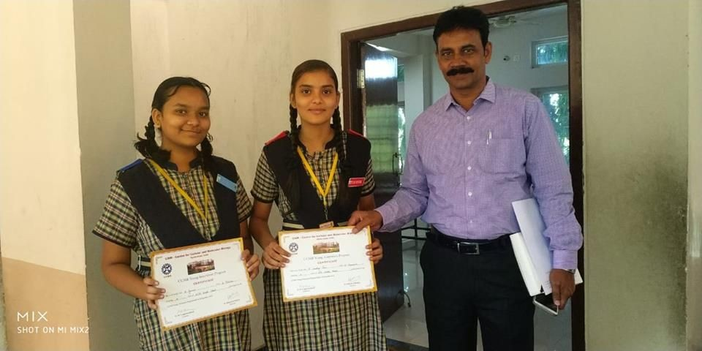

***COO- Education Mr.Y. Mohan Rao handing over the certificates***

1. Students of NTR High School - Warangal took part in The National Cadet Corps (NCC) training as an extracurricular activity. This training will inculcate the qualities of discipline and patriotism among school students. NCC aims at improving the overall personality of the school students so that their energy can be harnessed towards something useful for them as well as the society.

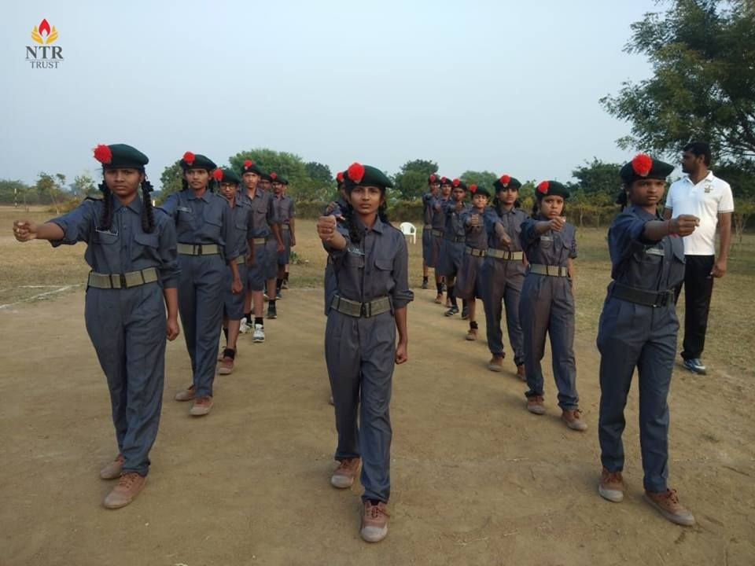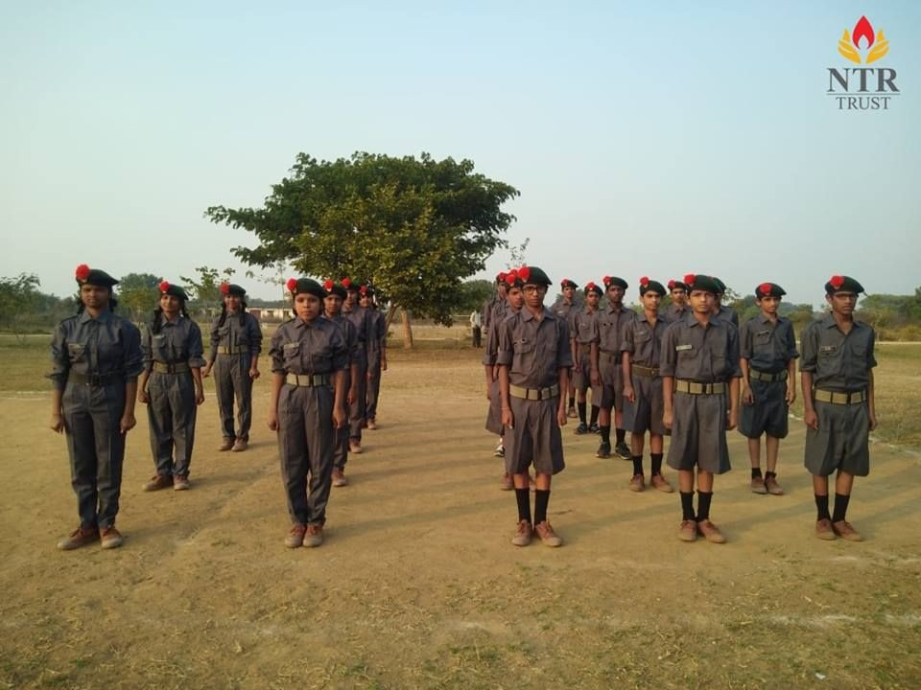

***Students during their NCC training @ NTR High School, Warangal***

1. An English Essay Writing Competition was held at NTR High School, Warangal. The students were asked to write on the topics "Conservation of Air, Water & Soil" or "Importance of Republic Day". The essay writing competition was judged on the basis of vocabulary, presentation and creativity. The purpose of this competition is to encourage the students to enhance their thinking & writing skills.

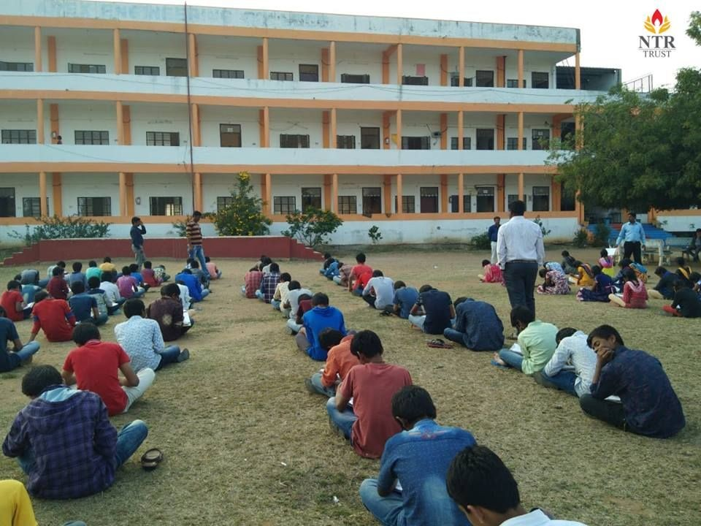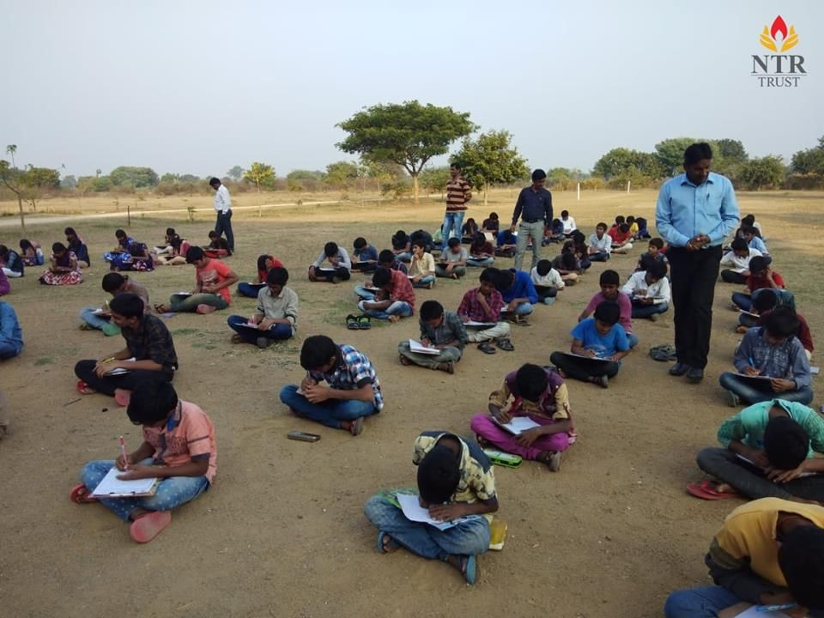

***Students during Essay Writing Competition @ NTR High School, Warangal***

1. We celebrated the 70th Republic Day with a lot of fervor and saluted our Indian flag with pride. Flag hoisting was done by COO-Education - Mr.Y. Mohan Rao at NTR Trust, Banjara Hills, Hyderabad and celebrations were held at NTR Model Schools in Gandipet, Hyderabad; Challapalli, and Warangal.

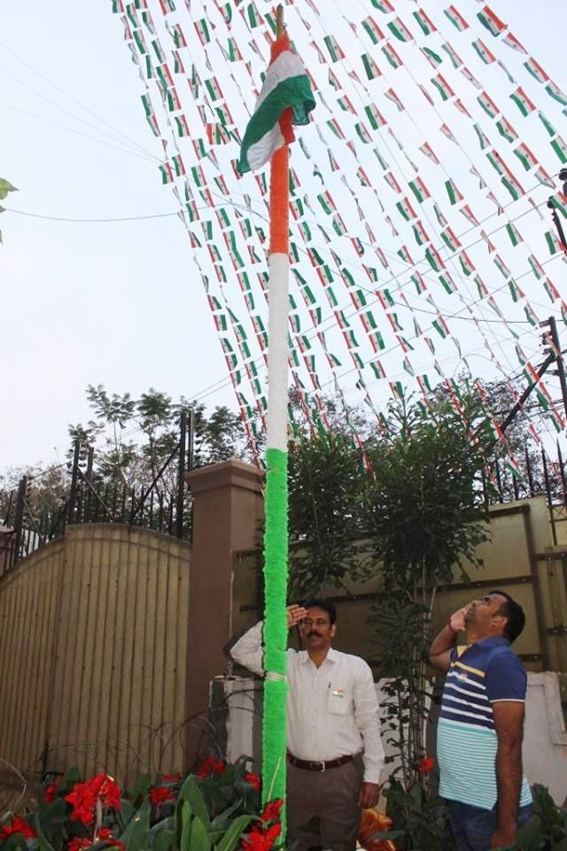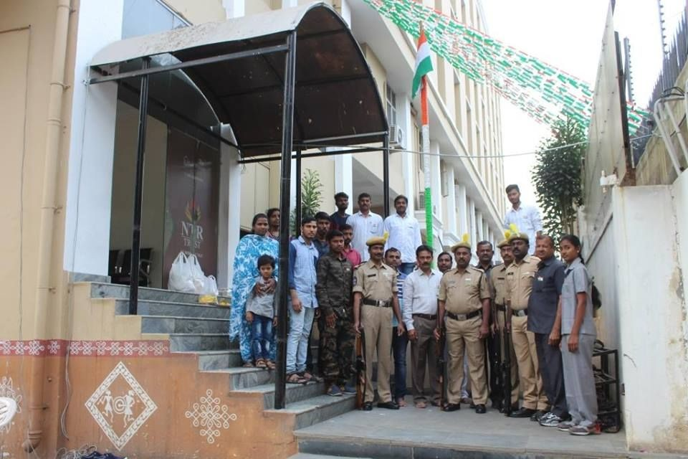

***Flag hoisting by COO-Education - Mr.Y. Mohan Rao @ NTR Trust , Hyderabad***

1. 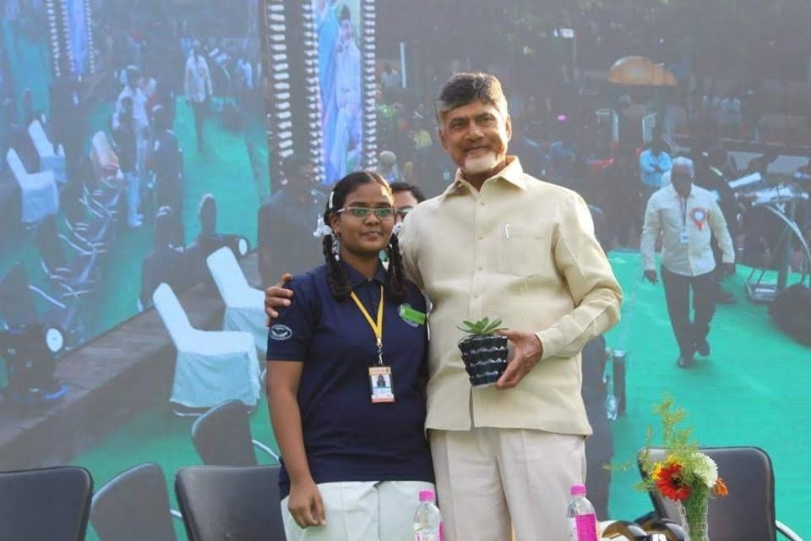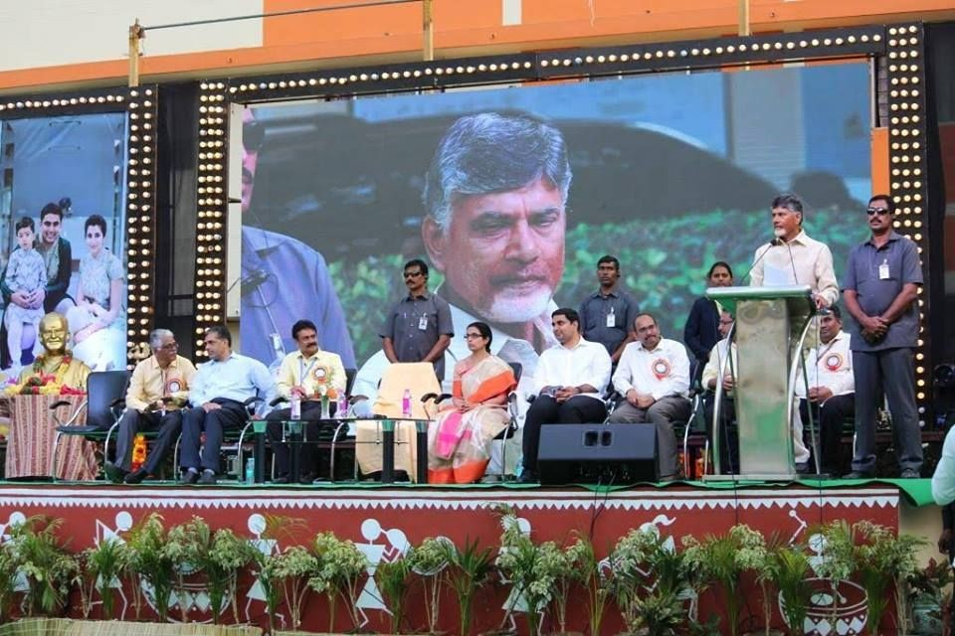TDP National President, Chief Minister of AP & Founder Trustee of NTR Trust, Sri Nara Chandrababu Naidu took part in Annual Day Celebrations at NTR Model School & College, Gandipet. He recalled his memories with late Sri N T Rama Rao garu and this campus which was his own school of learning about politics. He encouraged students to grab every available learning opportunity and prepare to become leaders in the future.

***Hon’ble Chief Minister of AP & Founder Trustee of NTR Trust, Sri Nara Chandrababu Naidu during the Annual Day celebrations at NTR Model School & College, Gandipet***

1. Hon'ble CM of Andhra Pradesh Sri Nara Chandrababu Naidu along with Managing Trustee Smt. Nara Bhuvaneshwari interacted with students from NTR High Schools studying in Challapalli and Warangal branches. The Chief Minister encouraged the kids to study hard to have a bright future and subsequently support the NTR Schools so that every generation can avail benefits from this kind of an institution.

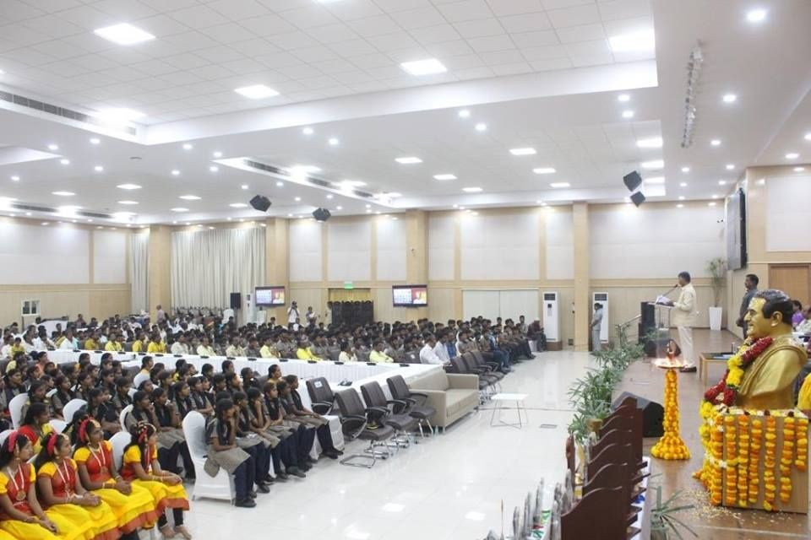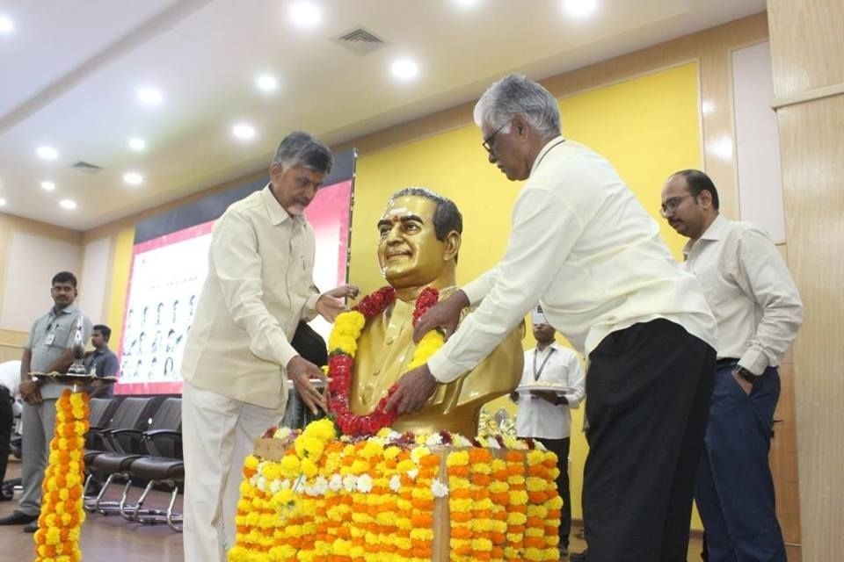

***Hon’ble Chief Minister of AP & Founder Trustee of NTR Trust, Sri Nara Chandrababu Naidu during his interaction with students from NTR High Schools in Amaravati***

# Press & Media Coverage:

1. [Vaartha - Vijayawada](https://drive.google.com/file/d/1y2IZVdiOCUN-GrQbck5NbiOV3G5859zQ/view?usp=sharing)
2. [Vaartha - Hyderabad](https://drive.google.com/file/d/1WMKPXPFKAtiAn_x7KKYovi8OI6ojtUWm/view?usp=sharing)
3. [Surya - Vijayawada](https://drive.google.com/file/d/1dKZHYM1VJs46B-Nkmcr0VCMmzDLGD8pY/view?usp=sharing)
4. [Surya - Hyderabad](https://drive.google.com/file/d/1Keogsp5htWRL5nMxlzj48wcmLenKKcvB/view?usp=sharing)
5. [Eendau - Hyderabad](https://drive.google.com/file/d/1GZA1qJO8VmQoCLRYEVU4NtiyNpAA8LPu/view?usp=sharing)
6. [Andhra Prabha -Hyderabad](https://drive.google.com/file/d/1TfKZwc4Cea-3TaLdNMq723rhr4pvS6JN/view?usp=sharing)
7. [Anhdra Jyothy - Hyderabad](https://drive.google.com/file/d/1b74XuHYRU-CrLHymtcQ_WisGTzHMI8jh/view?usp=sharing)
8. [Andhar Bhoomi - Hyderabad](https://drive.google.com/file/d/1An-zcMmXhkyjw-Mmeh7x-tGzj4hhG7hQ/view?usp=sharing)
   1. ["Young Innovators Program"(YIP)-CSIR- Centre for Cellular & Molecular Biology (CCMB), Hyd](https://www.facebook.com/ntrmemorialtrust/photos/pcb.1044161162458816/1044161035792162/?type=3&amp;theater) - NTRT Facebook
   2. [NCC at NTR High School - Warangal](https://www.facebook.com/pg/ntrmemorialtrust/photos/?tab=album&amp;album_id=1046827755525490&amp;__xts__%5B0%5D=68.ARAYeoll9hvfHKdl8QZFFvLHeOJeouI2RXmCFP7TO7AOwcWev1ipznTf_1lFkEQiFUqKdqriQzCt0S5AZJXirHZsg4BAQfukfk7yxOvAN8GPXdEIUVFRLahqY-Mur4Dt4TOa-TbhItpEHudBqkR-HpVAKXe3GWVJuRD3fW0xveK9w8PWA9FRw3PH_IGl5LGlD48dZi0EhoT0IbM2x01WYXO7z5aU9BEG2k1CR8qurKMiaBj-l0PpP8F3qbqfeSiAIg5zg4I8-r1jnQya3bwx-pIUX7S_1PJfPj4f6EBAeZNO5NHmFl6YD1nPSsFhgR4rv3-bJfRH0AOK7rdM_Z-Et_HjrocmH7vzjASBHXhIe6SnrQAuqLIkwoSZVq3NUl47NhCQ84icowI6NVhII6CK8qNPb3kF8_H2_KPF_r7uk-6UjJua6-hNTsCOrtXc2D8uUDCr6K9N-w28SMjGoiC0&amp;__tn__=-UC-R) - NTRT Facebook
   3. [Essay Writing Competition for NTR High School students](https://www.facebook.com/pg/ntrmemorialtrust/photos/?tab=album&amp;album_id=1048136635394602&amp;__xts__%5B0%5D=68.ARBOFqx9VO6JlU1DgVykp1Pi79l3cWifAdAwE1LrpoGcLVHSierV3oreEMzNz1_9NkjbpyKrd4N1L44Za3Zk7niFell1uwg3mnbNSqUPG_CcEqDk198paEUacXSpJFKeG1bJpdXuTmTykiGArtgCnCYpM36H3yz4aXKTan9EaiHUEb0H57rG0b_iW0IBHkouo-qgkB7V_T2yVuP9EAumZoSZxcBxXmqo96-oG47A9uO_OSK15XLcrzy3oNhxdIT-kkjbhRuuMQy84I6zn4PkC7JJDaW9eCr5BEPwOJLtLVfo_KHPYNRI_RUuEYyjFEJm2RYUpSKaiGsSf3aMWganehhR4Gl5hxg327eqOcokIAHiv2Z2s59MJq1k4uLYfYyt33-uxbtYz19Rs5V_q6qTtrPw3MbyOyYnvbZYk5SfVH0Xw5vdII715DM5CuyYSl2t0QN8KA-KDKXG-DtNbiyB&amp;__tn__=-UC-R) - NTRT Facebook
   4. [70th Republic Day Celebrated at NTR Trust](https://www.facebook.com/pg/ntrmemorialtrust/photos/?tab=album&amp;album_id=1059414910933441&amp;__tn__=-UC-R) - NTRT Facebook
   5. [Annual Day Celebrations of NTR Model School & College - Gandipet](https://www.facebook.com/pg/ntrmemorialtrust/photos/?tab=album&amp;album_id=1064560880418844&amp;__tn__=-UC-R) - NTRT Facebook
   6. [CM of AP Interacts with NTR Model School Students in Amaravati](https://www.facebook.com/pg/ntrmemorialtrust/photos/?tab=album&amp;album_id=1070142336527365&amp;__tn__=-UC-R) - NTRT Facebook

# [E](http://ntrtrust.org/empowerment-livelihoods/)mpowerment & Livelihoods Key Activities:

1. SRI G.V.Anjaneyulu MLA, Vinukonda & Smt. G. Leelavathi - Chairman of Siva Shakthi Leela Anjan Foundation, Distributed certificates to 120 candidates who have successfully completed 3 months courses in Sewing Machine Operator, Document Assistant, Retail Sales executive, Packer at NTR Trust- SDC-Vinukonda.

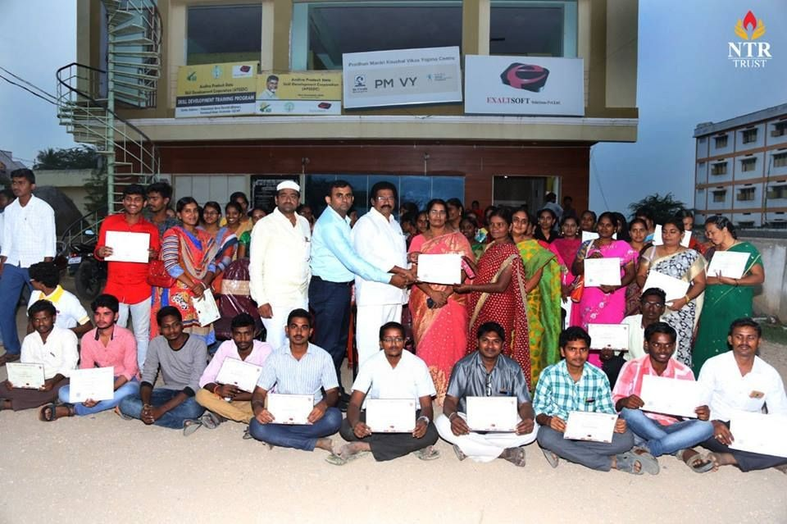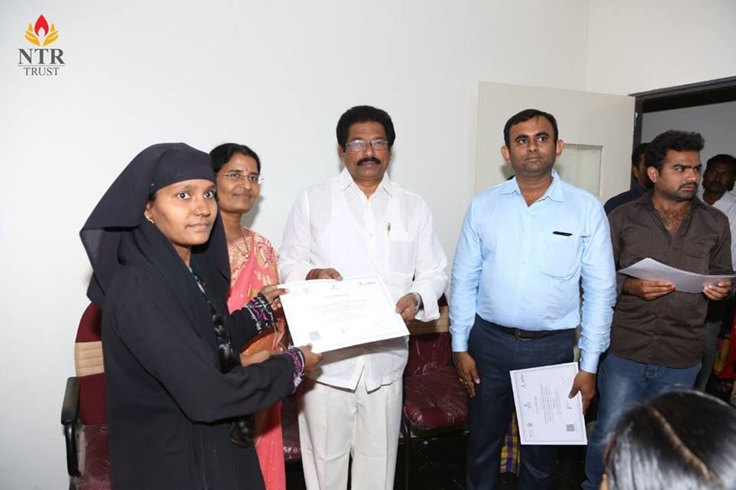

***Certificate distribution for Rural Women @ NTR Trust- SDC-Vinukonda***

1. Smt. G. Leelavathi - Chairman of Siva Shakthi Leela Anjan Foundation, gave a lecture to the candidates on the importance of the training which will help them to develop individually. She has also emphasized that there are ample number of employment and self-employment opportunities for women in Garment & Apparel industry. She distributed certificates to 40 candidates who have successfully completed 2 months of FREE training in Sewing Machine Operator, and Retail at NTR Trust SDC, Vinukonda.

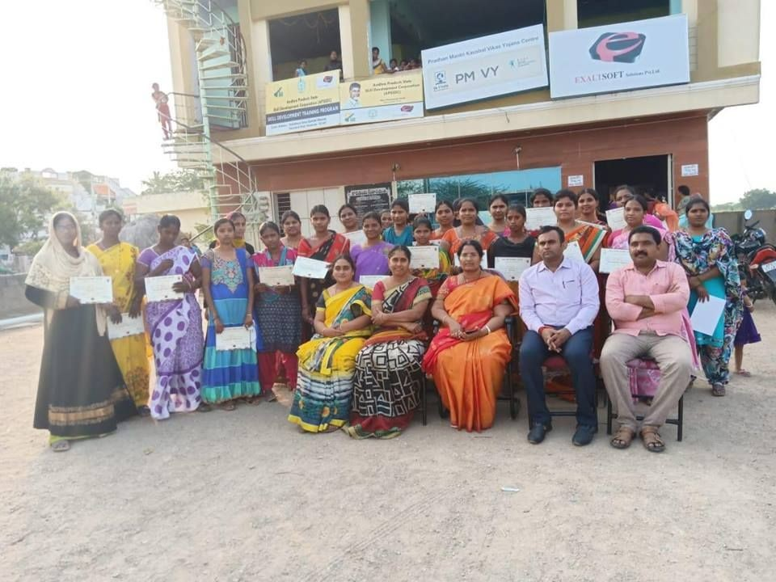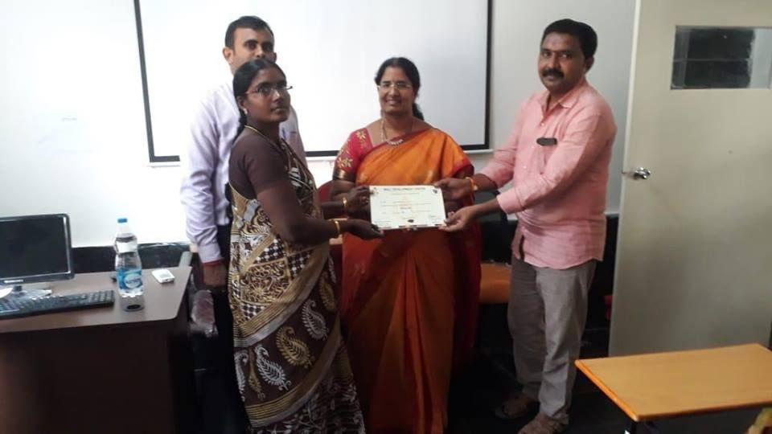

***Certificate distribution for Rural Women @ NTR Trust- SDC-Vinukonda***

1. NTR Trust organized a Job Drive at Skill Development Centre (SDC)-Hyderabad. More than 150 young aspirants attended the job drive. Renowned companies like IIC Technologies, GENPACT, KARVY, HDFC BANK, LMV financial Services were present. 90+ aspirants got offer letters.

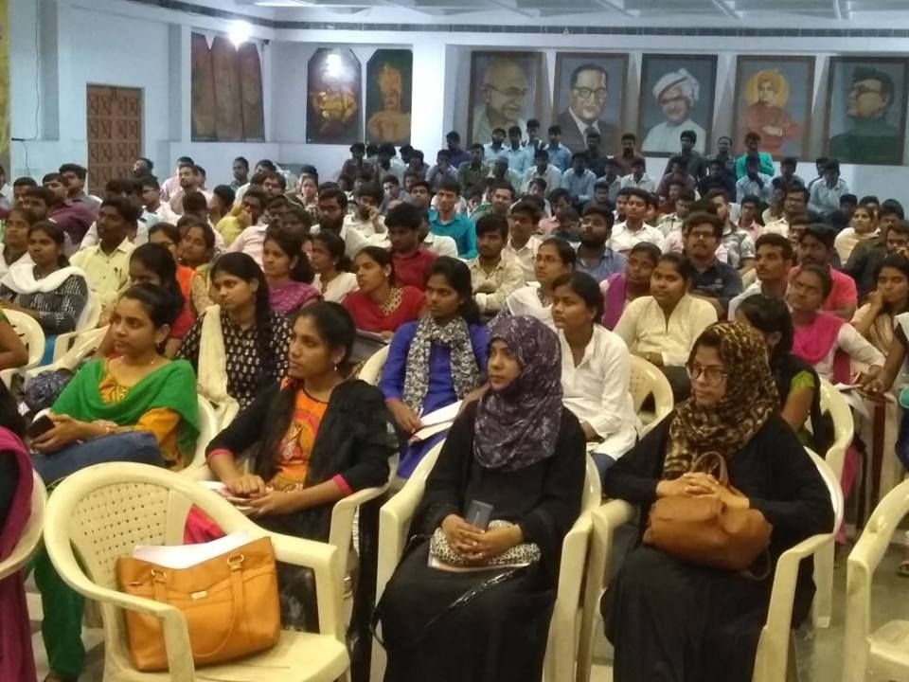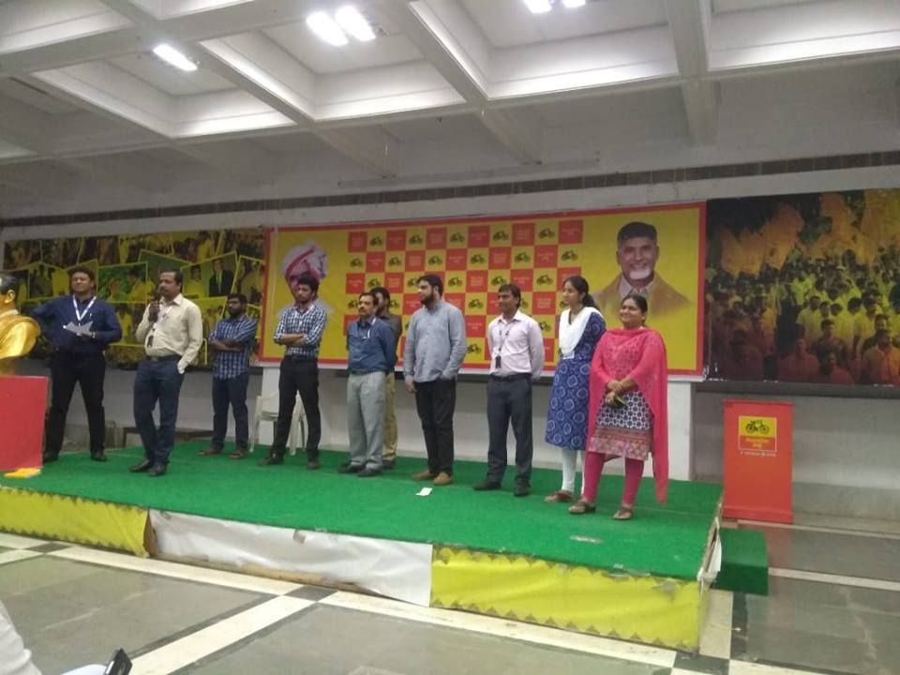

***Job aspirants during Job drive @NTR Trust-SDC-Hyderabad***

1. NTR Trust in collaboration with Canopy One Solutions, Inc., Madhapur, Hyderabad conducted a Job drive in Skill Development Centre (SDC) Hyderabad. More than 53 young job seekers attended the job drive. Please join us to wish the 22+ aspirants who got an offer letter.

# Press & Media Coverage:

1. [Course completion certificate distribution at NTR Trust,Vinukonda](https://www.facebook.com/pg/ntrmemorialtrust/photos/?tab=album&amp;album_id=1044778952397037&amp;__xts__%5B0%5D=68.ARBmFGYH3VszWSiZJs3RNqCc-6pjGBFvxYg1T4TMezDDH10i61CgYOqTVieGR7RRP-HPvu3Vv6GFOk10DqzhRHU1gKcDTFhSrQCscz5yEi5H98bJ-RKUylht7TAeqBgknlLZXJWQj6CwWU54ngIcecR1A6PfMeKJp4_3wV63krYwF8mHStY85IL5F4wGS2KtEzwPQPwZKgjPDjVmT3tsGYVMrV6YJtrM2gdOTsMv7RqeQLEaTilyTADZ1yolKgyRHpZ-ILxkL8GIjpwqRLVk_jXv2xui6ZcLl14NKRygtS-hUUVe8gtZWqNnvjr3YmIctjL8nvvnxzy2Uy8fxlsESlcMKo38m1Bae5QfowFhvlwBmShOQ4hyk1tb0xIe0Ak2qlsm7j4eEyzxdSRejA3cuXRlObG1eMGcUdIzGU7hZD8YOkmmd0QgkjAZNgYkyw3dcwslDgAYSV0TtjWZDHSW&amp;__tn__=-UC-R)- NTRT Facebook
2. [Course completion certificate distribution, NTR Trust ,Vinukonda](https://www.facebook.com/pg/ntrmemorialtrust/photos/?tab=album&amp;album_id=1071516359723296&amp;__tn__=-UC-R) - NTRT Facebook
3. [NTR Trust organized a Job Drive at our Skill Development Centre](https://www.facebook.com/pg/ntrmemorialtrust/photos/?tab=album&amp;album_id=1075944542613811&amp;__tn__=-UC-R) - NTRT Facebook
4. [NTR Trust organized a Job Drive at Hyderabad - SDC](https://www.facebook.com/pg/ntrmemorialtrust/photos/?tab=album&amp;album_id=1079149758959956&amp;__xts__%5B0%5D=68.ARAkOZSIrW5ho5e8smcCWku_MvHJ69k0NMeYCMYmpNcyLNjrM3O5GXhAXqagi7eq4IIMTedyMciICxo43gOu7V-ikC60IT5tg_dBUpFfsKzjUZB1p4CAfiFjH20_CT4P1Wc7V2sADBfmknEk7uYR_oKfUB7_ju_lEXULaS1fjmP1jDf0Eealj9qTjgsfYnC5eyxdzSvQTSFmCjIVGVdtEk96n-hwAHITZP_Fmr5xVWdStbK6EoWcLJ39N-CG8l_UhN84aoQ3pdFx_J4OmMr3AO36t7eBtiBaUltwfmWlVEnKZxvP-5ty7uvIbwOHs3CSa0oVLmXR6Cnqd-lmnQuYuyqsr8kNgWtES10EYxhE7y925qp2JkNQBq9A3ML39w40Yjgrp5X2RswdKTIYGRpFj6OR4Huci4HqlDr3BIkLaSzwhScBDjGyWX82vjFIu2WApL1dsvWJepby0i2GRzVx&amp;__tn__=-UC-R) -NTRT Facebook

# Other Activities :

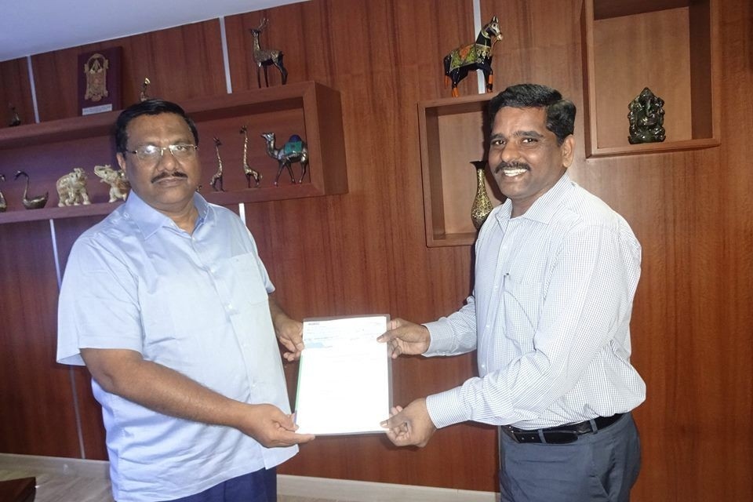1. We thank Shri. K.Nityananda Reddy - Managing Trustee - Aurobindo Pharma Foundation for Donating of Rs.60,00,000/- (Rupees Sixty lakhs only) to NTR Trust. This donation will help NTR Trust to establish a new Blood Bank in Tirupati, Chittoor District, Andhra Pradesh State.

***Shri. K.Nityananda Reddy - Managing Trustee - Aurobindo Pharma Foundation handing over the donation***

# Press & Media Coverage:

1. [Aurobindo Pharma Foundation Donation to NTR Trust](https://www.facebook.com/ntrmemorialtrust/photos/a.131336557074619/1080410825500516/?type=3&amp;theater) -NTRT Facebook

# About NTR TRUST

Established in 1997, NTR Trust has been at the forefront of bringing socio-economic change in Andhra Pradesh and Telangana states. It endeavours to create opportunities for the underprivileged to achieve their full potential, safeguarding health and safety and reducing poverty and instances of injustice. Our work is guided by an important principle: that we are guardians of private funds which must be utilized in the public interest. We are inspired by NTR’s deeply held belief: that sharing and caring are the ultimate goals of human life.

**Follow us:** [Facebook](https://www.facebook.com/ntrmemorialtrust?fref=ts) [Website](http://ntrtrust.org/) [Twitter](https://twitter.com/ntrtrust)

# Support us:

Donors can donate to NTR Trust using a debit card or credit card issued by any bank. We use HDFC bank payment gateway services for managing and maintaining transaction processes. If you are an Indian citizen with an Indian passport or an overseas donor who files tax returns in India, then you can avail 50% tax exemption under Indian I.T Act u/s 80G of

I.T Act 1961. You can track online donations made to NTR memorial Trust. You or your team can [view donations](http://ntrtrust.org/donations/) made to the Trust, enabling you to track the impact of your donations.

Thanks and regards

# Mr. K. Rajendra Kumar-IPS (Retd)

**Chief Executive Officer, NTR Trust**

*[To Subscribe or Unsubscribe to NTR Trust e-Newsletter email on* [*info@ntrtrust.org*](mailto:info@ntrtrust.org) *]*